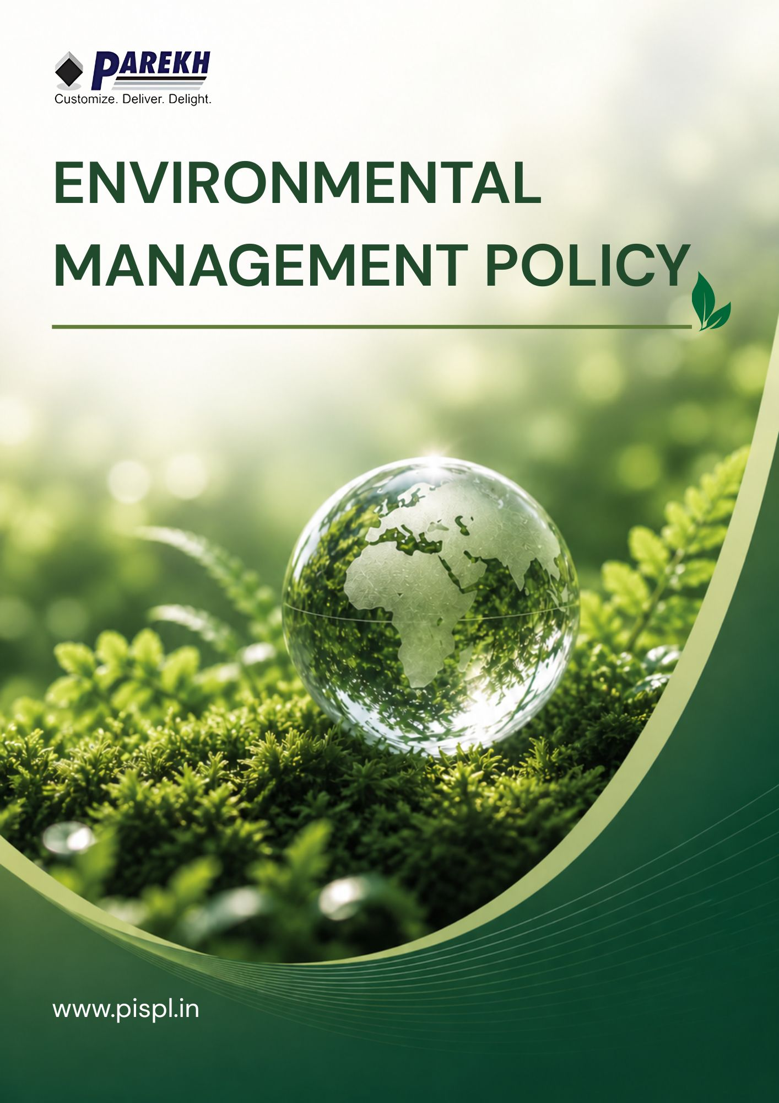

Contents
Introduction 3
Scope 3
Purpose 4
Key Focus Areas 4
Our Commitments & Approach 5
Covered SDGs by this Policy 9
Roles and Responsibilities towards this policy 9
Continuous Improvement 10
Review Mechanism 10
Acknowledgement 11

Introduction
Parekh Integrated Services Pvt. Ltd. (PISPL) is committed to conducting its logistics, warehousing, and supply chain operations in an environmentally responsible and sustainable manner. The Company recognizes its responsibility to minimize environmental impacts, conserve natural resources, and contribute to climate change mitigation through continuous improvement in environmental performance. PISPL integrates sustainability into its operations through energy efficiency, renewable energy adoption, responsible resource use, waste reduction, and green building practices.

Scope
This policy applies to all PISPL operations, including warehouses, transportation, and office locations across all national and international locations. It covers all permanent, temporary, and contract employees across all functions, as well as all internal and external stakeholders associated with the PISPL Group, whether directly or indirectly.
Sr. No. | Name of Operational Unit | (Corporate / Warehouse) | Registered Address of the Unit
1 | HO | Corporate | Parekh Integrated Services Pvt. Ltd., C/o Parekh Prints, 1st Floor, Italian Textile Compound, ITT Bhatti, Off Goregaon Mulund Link Road, Goregaon (E), Mumbai - 400 063
2 | BOM 2 | Warehouse | BOM 2 LC, Parekh Integrated Services Pvt. Ltd., BGR Realities Pvt. Ltd., Ware-House No:- 10, Village:-Vahuli, NH-3 Road, Bhiwandi - 421302.
3 | BOM 3 | Warehouse | BOM 3 LC, Parekh Integrated Services Pvt. Ltd., BGR Realities Pvt. Ltd., Ware-House No:- 6, Village:-Vahuli, NH-3 Road, Bhiwandi - 421302
4 | BOM 4 | Warehouse | BOM 4 LC, Parekh Integrated Services Pvt. Ltd., Warehouse 7B, BGR Logistics Park, Village:-Vahuli, Padgha, Bhiwandi - 421302.
5 | CCU 1 | Warehouse | CCU 1 LC, Parekh Integrated Services Pvt. Ltd., Co. Mayur Ply Pvt. Ltd., Serampore, NH-2, Old Delhi Road, Belumlki, Sheoraphuli, Hooghly- 712223, West Bengal. Land mark: Belumore, Opp Royal Hotel.
6 | DEL 1 | Warehouse | DEL 1 LC, Parekh Integrated Services Pvt. Ltd., Village Bhangrola, Sector M 12, Manesar, Dist: Gurugram, Haryana 122505
7 | MAA 2 | Warehouse | MAA 2 LC, Parekh Integrated Services Pvt. Ltd., A-07 Block, M/s RAR Retail and Infra LLP, Chinnambedu Village, Ponneri Taluk, Thiruvallur District, Tamil Nadu 601206
8 | MAA 3 | Warehouse | MAA 3 LC, Parekh E-Com and Warehousing Services Pvt. Ltd., 117/3C and 3D, Padmavathi Garden, Numbal, Thiruverkadu P.O., Chennai, Tiruvallur, Tamil Nadu 600071
9 | BLR 2 | Warehouse | BLR 2, Parekh Integrated Services Pvt. Ltd., C/o Siemens Healthineers, Survey No. - 121/1, 121/2, Dandupalya Village, Kasaba Hobli, Hoskote - Kadapa Highway, Hoskote Taluk, Bangalore-562114
10 | TVM 1 | Warehouse | TVM 1 LC, Parekh Integrated Services Pvt. Ltd., Rajadhani Warehouse, Behind Popular Tata Motors, Pallichal P.O, Trivandrum, Kerala 695020
11 | South Stock Points | Warehouse | Bengaluru, Chennai, Cochin, Coimbatore, Hubli, Hyderabad, Madurai, Mangalore, Trichy, Trivandrum, Vellore, Vijayawada
12 | West Stock Points | Warehouse | Ahmedabad, Aurangabad, Baroda, Goa, Nagpur, Pune, Rajkot, Surat
13 | East Stock Points | Warehouse | Chandrasekharpur, Guwahati, Indore, Jabalpur, Kolkata, Patna, Raipur, Ranchi
14 | North Stock Points | Warehouse | Chandigarh, Dehradun, Dharuhera, Jaipur, Jalandhar, Jodhpur, Karnal, Lucknow, Ludhiana, Srinagar

Purpose
The purpose of this Environmental Policy is to establish a structured framework for managing environmental impacts associated with the operations of Parekh Integrated Services Pvt. Ltd. (PISPL). This policy aims to ensure that environmental considerations are integrated into business decision-making, operational activities, and long-term strategic planning. It defines the Company’s commitment to regulatory compliance, resource efficiency, pollution prevention, and continuous improvement in environmental performance.

Key Focus Areas
- Air Quality Management: Focus on minimizing emissions from transportation and operations through improved fuel efficiency, adoption of cleaner technologies, and regular monitoring practices.
- Water Stewardship: Focus on responsible water use, conservation, recycling, and reducing dependence on freshwater resources across all facilities.
- Resource and Waste Optimization: Focus on reducing material consumption, minimizing waste generation, promoting reuse and recycling, and ensuring safe handling, storage, and disposal of materials and chemicals.
- Climate and Energy Efficiency: Focus on enhancing energy efficiency, reducing reliance on fossil fuels, and lowering greenhouse gas emissions through operational improvements and renewable energy adoption.
- Ecosystem and Land Management: Focus on conserving biodiversity, protecting natural habitats, increasing green cover, and minimizing environmental impacts from infrastructure and operations.
- Product Safety and Environmental Responsibility: Focus on ensuring safe, compliant, and environmentally responsible handling, storage, and transportation of goods in line with applicable standards.

Our Commitments & Approach
- Air Quality Management
- We strive to adopt cleaner fuels and environmentally friendly technologies by promoting low-emission alternatives and energy-efficient systems.
- Control and minimize emissions of VOCs, SOx, and NOx from warehouse operations by ensuring proper maintenance of diesel-operated equipment, generators, and vehicles, and by adopting cleaner fuel alternatives where feasible.
- Prevent air contamination from storage and handling activities involving volatile substances (VOCs) by ensuring proper sealing, labelling, and controlled storage of chemicals, fuels, or other emission-prone materials.
- We will maintain all vehicles and equipment regularly to ensure reduced emissions through scheduled inspections and preventive maintenance.
- We commit to minimizing air emissions from our transportation and warehouse operations by improving route efficiency and reducing fuel consumption.
- We strive to improve indoor air quality across all facilities through proper ventilation, monitoring, and maintenance systems.
- We will ensure that 100% of paints and adhesives used are low VOC and GreenPro certified or equivalent by 2026-27 from the baseline FY 2022-23.
- We will ensure 100% vehicle emission certification (PUC) compliance annually from FY 2023–24 onwards.
- We will conduct annual emission testing for all diesel generators through FY 2029-30.
- We commit to implementing dust control measures in all warehouse facilities by FY 2024–25, from FY 2022–23 baseline.
- We aim to train all drivers in eco-driving practices by FY 2024–25, using FY 2022–23 baseline.
- We ensure full compliance with applicable emission norms from FY 2022-23 onwards.
- We will conduct annual air quality monitoring at major facilities through FY 2029-30.
- Customer Health & Safety
- We commit to ensuring the safety and integrity of all customer products handled within our operations by implementing quality control measures and secure handling practices.
- We will ensure maintain high standards of hygiene and safety in all warehouse environments through regular cleaning, inspections, and adherence to safety protocols.
- We will implement robust systems for incident reporting and corrective action by establishing clear reporting procedures and timely resolution mechanisms.
- We strive to maintain strict temperature control for sensitive products through continuous monitoring and calibrated storage systems.
- We commit to achieving zero major customer safety incidents annually from baseline FY 2023–24 to FY 2029-30.
- We will maintain 100% compliance with applicable quality and safety standards throughout the target period by FY 2029-30.
- We aim to reduce product damage incidents by 5% by FY 2029-30, compared to FY 2022–23.
- We aim to maintain at least 95% on-time delivery performance for sensitive shipments through FY 2029-30.
- Climate and Energy Efficiency
- We commit to progressively lowering energy consumption across all our facilities by adopting efficient technologies and responsible operational practices.
- We strive to embed energy conservation into daily operations through employee awareness and engagement.
- Increase the use of renewable energy within warehouse operations by expanding existing rooftop solar infrastructure and optimizing its utilization to reduce dependence on conventional energy sources.
- We are committed to monitoring and managing greenhouse gas emissions in a structured and transparent manner.
- We will prioritize procurement of energy-efficient equipment across all facilities by selecting high-efficiency and low-energy consumption alternatives.
- We strive to align our logistics operations with low-carbon practices over time by optimizing routes and adopting cleaner transportation methods.
- We aim to incorporate sustainability considerations into all infrastructure expansion decisions by evaluating environmental impact and adopting green building practices.
- PISPL targets 50% of its power consumption to be sourced from on-site solar photovoltaic (PV) systems. We will invest in the installation, maintenance, and expansion of solar PV infrastructure to generate clean energy and reduce reliance on the grid.
- We will ensure that 100% of air conditioning units comply with ECBC 2017 (or latest) efficiency standards and use CFC/HCFC-free refrigerants by 2029-30 from the baseline FY 2022-23.
- We commit to ensure that 100% of transformers comply with ECBC 2017 (or latest) efficiency standards by 2029-30 from the baseline FY 2022-23.
- We will ensure that 100% of DG sets comply with ECBC 2017 (or latest) efficiency standards by 2029-30 from the baseline FY 2022-23.
- We aim to ensure that 100% of plumbing pumps and motors comply with ECBC 2017 (or latest) efficiency standards by 2029–30from the baseline FY 2022-23.
- We will achieve a 5% reduction in electricity consumption intensity by FY 2029-30, compared to FY 2022–23.
- We commit to ensuring 100% LED lighting coverage across all facilities by FY 2024–25, using FY 2022–23 as the baseline.
- We aim to source at least 10% of total energy from renewable sources by FY 2029-30, against FY 2022–23 levels.
- PISPL commits to reducing GHG emissions Scope 1 ,2 and 3 by 15% by FY 2029-30 from baseline of FY 2022-23. This reduction target will be measured based on a comprehensive assessment of our emissions inventory, including direct (Scope 1) and indirect (Scope 2 and Scope 3) emissions.
- We strive to reduce overall carbon intensity by 5% by FY 2029-30, compared to FY 2022–23.
- We will conduct energy audits at all major facilities at least once every 2 years up to FY 2029-30.
- We will train at least 90% of relevant employees on energy conservation and GHG management practices by FY 2029-30, compared to FY 2022–23 baseline data.
- We commit to achieving a 5% improvement in HVAC/cold storage energy efficiency by FY 2029-30, compared to FY 2022–23.
- Resource and Waste Optimization
- We commit to optimizing material usage and minimizing waste generation across operations by improving material planning and reducing excess consumption.
- We will promote recycling, reuse, and responsible disposal practices by implementing structured waste management programs and awareness initiatives.
- We strive to ensure safe handling and storage of all chemicals through proper labelling, training, and adherence to safety protocols.
- We will implement waste segregation at source across all facilities by providing designated bins and clear segregation guidelines.
- We are committed to full compliance with waste management regulations by adhering to applicable laws and conducting regular compliance checks.
- We strive to strengthen partnerships with authorized recycling vendors by engaging certified agencies and monitoring their performance.
- We aim to maintain complete transparency in hazardous waste handling by ensuring proper documentation and reporting practices.
- We will continuously improve waste management systems and practices through regular reviews and adoption of best practices.
- We commit to ensure that 100% of housekeeping chemicals are Green Seal / GreenPro certified or equivalent by 2026-27 from the baseline FY 2022-23.
- We will ensure that 100% of fertilizers used in campus operations are organic by 2026-27 from the baseline FY 2022-23.
- We will ensure that at least 20% of materials procured contain recycled content as per industry norms.
- We will ensure that 100% of engineered wood products are free from added urea formaldehyde by 2029–30from the baseline FY 2022-23.
- We will ensure that at least 50% of wood used is sourced as salvaged wood, certified wood (FSC/PEFC), rapidly renewable, or urea-formaldehyde-free composite wood by 2029–30 from the baseline FY 2022-23.
- We will achieve 100% waste segregation at source by FY 2024–25, from FY 2022–23 baseline.
- We aim to recycle or reuse at least 70% of non-hazardous waste by FY 2029-30, compared to FY 2022–23.
- We commit to ensuring 100% disposal of hazardous waste through authorized vendors from FY 2023–24 onwards.
- We will ensure at least 90% of relevant employees are trained on waste segregation, chemical handling, and disposal practices by FY 2029-30, compared to FY 2022–23.
- We will maintain 100% chemical inventory records and MSDS availability from FY 2023–24 onwards.
- We aim to reduce damaged or expired inventory waste by 5% by FY 2029-30, compared to FY 2022–23.
- We will ensure at least 90% of relevant employees are trained on waste segregation, chemical handling, and disposal practices by FY 2029-30, compared to FY 2022–23.
- We ensure full compliance with hazardous waste regulations throughout FY 2023–24 to FY 2029-30.
- Water Stewardship
- We commit to using water responsibly and reducing consumption across all operations by implementing efficient usage practices and conservation measures.
- Strengthen water conservation practices within warehouse operations by maintaining and optimizing the existing rainwater harvesting system, and implementing reuse mechanisms supported by appropriate infrastructure and monitoring systems.
- We aim to regularly monitor water consumption and identify improvement opportunities through periodic tracking and analysis.
- We will promote reuse and recycling of water wherever operationally feasible by implementing treatment and reuse systems.
- Incorporate water-efficient systems in warehouse facility designs by implementing low-flow and sensor-based fixtures, dual-flush systems, rainwater harvesting integration, greywater reuse, and leak detection with efficient planning practices.
- We will encourage employees to adopt responsible water usage practices through training and awareness programs.
- We aim to ensure that 100% of water plumbing fixtures comply with flow rates as per Uniform Plumbing Code India 2016 by 2026-27 from the baseline FY 2022-23.
- We will achieve a 5% reduction in water consumption intensity by FY 2029-30, compared to FY 2022–23.
- We commit to installing rainwater harvesting systems in at least 10% of owned facilities by FY 2029-30, from FY 2022–23 baseline.
- We will ensure all identified leaks are rectified within 48 hours throughout FY 2023–24 to FY 2029-30.
- We aim to reuse at least 10% of treated water by FY 2029-30, compared to FY 2022–23.
- We will track water usage annually across all major facilities starting FY 2023–24.
- We commit to installing water meters in 80% of facilities by FY 2029-30, against FY 2022–23 baseline.
- We will reduce potable water usage in non-essential activities by 5% by FY 2029-30, compared to FY 2022–23.
- We will conduct annual awareness programs on water conservation through FY 2029-30.
- We aim to reduce water usage by 5% by FY 2029-30, compared to FY 2022–23.

Covered SDGs by this Policy
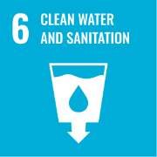 | 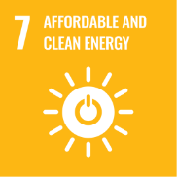 |  | 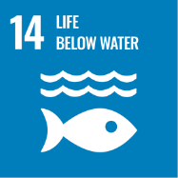 | 

Roles and Responsibilities towards this policy
Board of Directors
- Provide overall strategic direction and ensure integration of environmental and sustainability considerations into business decisions.
- Approve the ESG Policy and ensure alignment with organizational objectives and regulatory requirements.
- Allocate adequate resources for implementation of sustainability initiatives and achievement of targets.
- Periodically review ESG performance, risks, and progress against defined targets.
- Promote a culture of accountability and sustainability across the organization.
Top Management
- Demonstrate commitment towards implementation of ESG objectives and targets across all operations.
- Ensure integration of sustainability practices into business strategy and operational planning.
- Provide necessary support and resources for effective policy implementation.
- Review performance against qualitative objectives and quantitative targets on a periodic basis.
- Ensure compliance with all applicable environmental and safety regulations.
ESG / Sustainability Head
- Review the policy regularly.
- Drive implementation of ESG initiatives across all functions and facilities.
- Monitor and track performance against targets
- Develop procedures, frameworks, and reporting systems for ESG management.
- Coordinate data collection, validation, and reporting for internal and external disclosures.
- Identify improvement opportunities and support continuous enhancement of ESG performance.
Facility Management
- Implement energy, water, waste, and environmental practices at site level.
- Ensure efficient use of resources and adherence to operational controls.
- Maintain equipment and infrastructure to meet efficiency and emission standards.
- Ensure proper waste segregation, handling, and disposal practices.
- Maintain records and provide required data for ESG monitoring and reporting.
Transport and Logistics Team
- Optimize transportation routes and load planning to improve fuel efficiency.
- Ensure all vehicles comply with emission standards and regulatory requirements.
- Monitor fuel consumption and transportation-related emissions.

Continuous Improvement
PISPL commits to continuously improving its environmental and sustainability performance by enhancing efficiency in energy, water, waste, emissions, and safety management. The Company will adopt best practices, promote employee awareness, and integrate learnings from audits and feedback to drive ongoing improvements.
Reporting
PISPL will establish structured reporting mechanisms to track environmental and sustainability performance across key areas. The Company will ensure periodic internal reporting, maintain accurate records, and communicate progress to relevant stakeholders as required.

Review Mechanism
PISPL will annually or as per requirement review this policy and its targets to ensure effectiveness and alignment with business and regulatory requirements. The review will be conducted by the ESG / Sustainability Head. The Company will update actions based on review findings, ensure closure of corrective actions, and maintain proper documentation for audit purposes.
Documnet no.: DOC.PISPL.POL.001
Effective Date: 01-01-2025
Last Review Date: 01-01-2026 Rev. No: 1.0
Next Review Date: 01-01-2027

Approved By:
General Manager (PISPL Group)

Acknowledgement
I, the undersigned, acknowledge that I have received, read, and understood the Environmental Management Policy of PISPL Group. I understand the Company’s commitment to environmental sustainability, responsible resource management, customer safety, and regulatory compliance.
I understand that:
- I am personally responsible for complying with this policy and all applicable environmental, health, safety, and regulatory requirements.
- I must use resources such as energy, water, and materials responsibly and support waste reduction and environmental protection initiatives.
- I must follow all procedures related to safe handling, storage, and transportation of materials and customer goods.
- I must promptly report any environmental, safety, or compliance concerns, incidents, or violations in good faith.
- Failure to comply with this policy may result in disciplinary action, including termination and legal consequences.
By signing this acknowledgement, I commit to supporting the Company’s ESG objectives and conducting myself in a manner consistent with this policy and its targets.

Employee Name: ____________________
Designation: ____________________
Department: ____________________
Date: ____________________
Signature: ____________________

